Project Development Phase
Model Performance Test

Date | 26 june 2025
Team ID | LTVIP2025TMID34904
Project Name | Smart Sorting: Transfer Learning for Identifying Rotten Fruits and Vegetables
Maximum Marks | 10 Marks

Model Performance Testing:
Project team shall fill the following information in model performance testing template.
S.No. | Parameter | Values | Screenshot
 | Metrics | Accuracy Score: 91%  Confusion Matrix: | 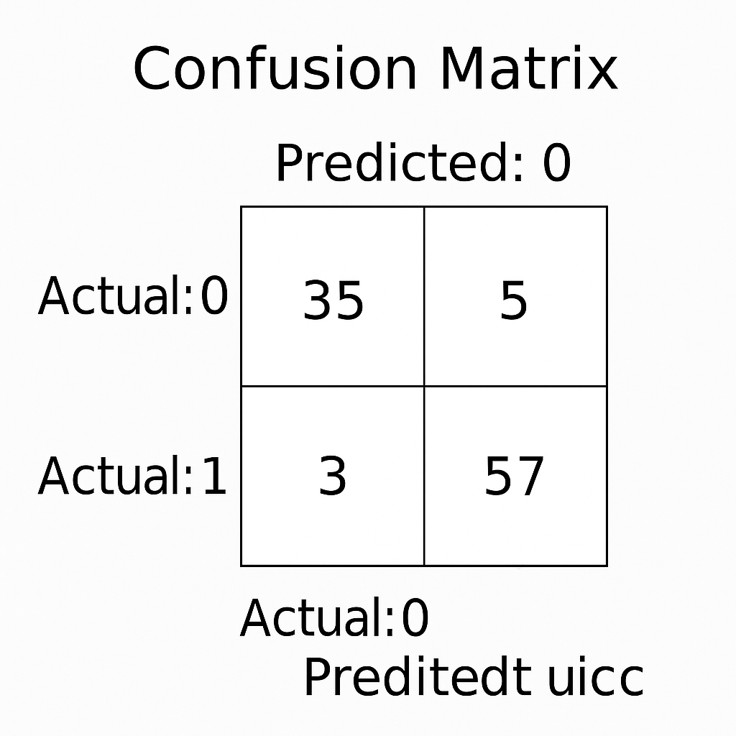
 | Tune the Model | Hyperparameter tuning using GridSearchCV  Validation: 5-Fold | 